Live Life to the Full …..

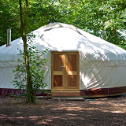

**The Houghton Project** is delighted to deliver a **10 week** Social Skills & Problem Solving Program for 15-19 year olds.

This program will offer young people experiencing low mood or difficulty coping with stress the opportunity to generate more **effective solutions** to difficult situations.

Using a Cognitive Behavioural Therapeutic approach this course will offer small group work in a beautiful setting, as well as practical opportunities to implement skills acquired through the program for young people to live their lives to the full.

For further information please contact Jenny James-Moore on 07789915540

or the Houghton Project on 01568797900.

The first course will start at the end of April, there are limited places available.

Small fee of £8.50 per session

